**Ideation Phase**

**Define the Problem Statements**

|  |  |
| --- | --- |
| Date | 16 June 2025 |
| Team ID | LTVIP2025TMID35624 |
| Project Name | Revolutionizing Liver Care: Predicting Liver Cirrhosis Using Advanced Machine Learning Techniques |
| Maximum Marks | 2 Marks |

**Customer Problem Statement Template:**

Liver cirrhosis is a life-threatening condition that often goes undetected until it reaches an advanced stage. Early diagnosis is critical for effective treatment and improved survival rates, yet traditional diagnostic methods are invasive, time-consuming, and costly. This project aims to transform liver care by applying advanced machine learning techniques to predict liver cirrhosis from non-invasive clinical and laboratory data. By uncovering hidden patterns in patient data, the system provides accurate, early-stage predictions-enabling timely interventions and personalized healthcare solutions.

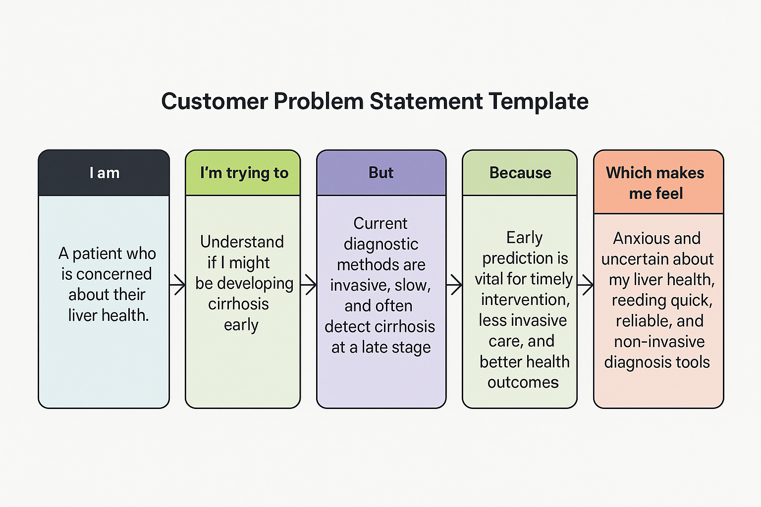

|  |  |  |  |  |  |
| --- | --- | --- | --- | --- | --- |
| **Problem Statement (PS)** | **I am (Customer)** | **I’m trying to** | **But** | **Because** | **Which makes me feel** |
| PS-1 | A patient who is concerned about their liver health | Understand if I might be developing cirrhosis early | Current diagnostic methods are invasive, slow, and often detect cirrhosis at a late stage | Early prediction is vital for timely intervention, less invasive care, and better health outcomes | Anxious and uncertain about my liver health, needing quick, reliable, and non-invasive diagnosis tools |
| PS-2 | A middle-aged person with a family history of liver disease | Know my risk of developing liver cirrhosis early | I don’t get regular checkups because the tests are expensive and invasive | Knowing my risk early can help me make lifestyle changes and seek medical attention in time | Worried and helpless due to lack of affordable and accessible diagnosis |
| PS-3 | A healthcare provider managing multiple liver patients | Identify early-stage cirrhosis in patients efficiently | Traditional diagnosis takes time and often misses early signs | Early and accurate predictions can improve patient care and outcomes | Frustrated and overwhelmed due to delays and limited diagnostic precision |
| PS-4 | A patient with symptoms like fatigue and jaundice | Understand if it could be liver cirrhosis or something else | Symptoms are vague and doctors need invasive tests to confirm | A clear, data-driven prediction could reduce uncertainty and speed up diagnosis | Anxious and confused, needing clarity and fast results without invasive procedures |